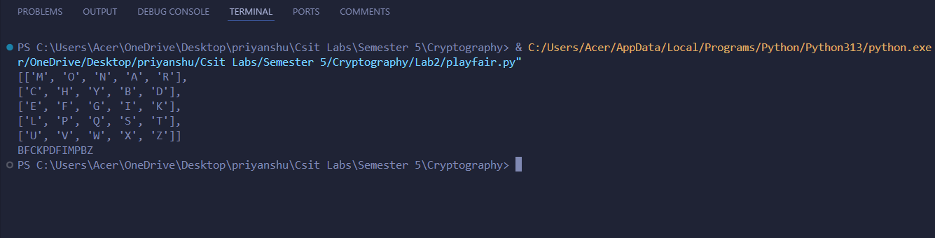
- PlayFair Cipher Output:

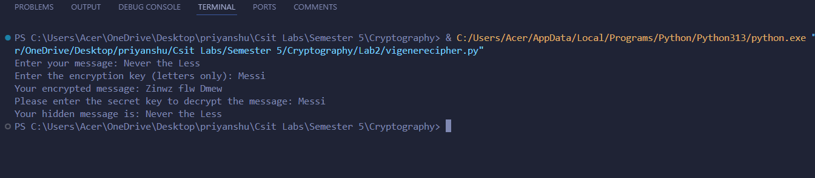
- Vigenere Cipher Output:

